WhiteBox Testing
TV DESA Kota Batu

Version | By | Description
01 | Muhammad Rafid MPS | Whitebox Testing using the Statement Coverage, … and, … Techniques

Tugas Pre-Prakktikum

- Contoh Pengerjaan menggunakan Statement Coverage

$$Statement coverage= \frac{Number of executed statements}{Total number of statements}×100\%$$
- Login Aplikasi
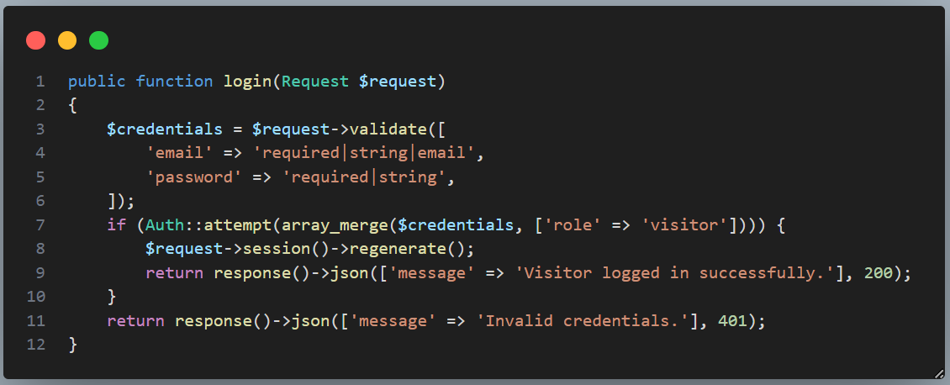

Scenario 1 :
Jika melakukan verifikasi login dengan data yang valid
$$Statement coverage= \frac{11}{12}×100\%=91,6\%$$

Scenario 2 :
Jika melakukan verifikasi login dengan salah satu data yang kosong
$$Statement coverage= \frac{8}{12}×100\%=66,6\%$$

Scenario 3 :
Jika melakukan verifikasi login dengan data yang tidak valid
$$Statement coverage= \frac{10}{12}×100\%=83,3\%$$

TC ID# | Input | Output | Statement Coverage | Status
TC-1 | Mengecek verifikasi login dengan data yang valid | Menampilkan notifikasi “Login successful” | $$\frac{11}{12}×100\%=91,6\%$$ | Berhasil
TC-2 | Mengecek verifikasi login dengan salah satu data yang kosong | Menampilkan notifikasi “An error occured, please try again” | $$\frac{8}{12}×100\%=66,6\%$$ | Berhasil
TC-3 | Mengecek verifikasi login dengan data yang tidak valid | Menampilkan notifikasi “Invalid Credentials” | $$\frac{10}{12}×100\%=83,3\%$$ | Berhasil
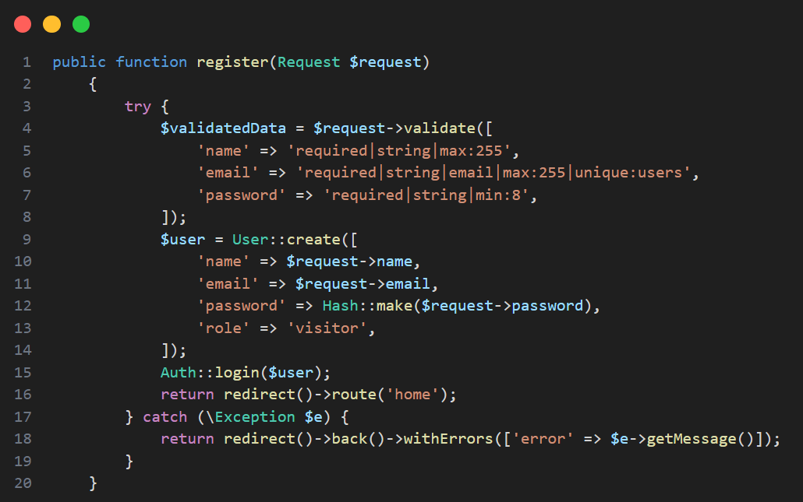

- Register

Scenario 1 :
Melakukan register dengan data yang valid

$$Statement coverage= \frac{18}{20}×100\%=90\%$$

Scenario 2 :
Melakukan register dengan data tidak valid
$$Statement coverage= \frac{12}{20}×100\%=60\%$$

Scenario 3 :
Melakukan register dengan email yang sudah terdaftar
$$Statement coverage= \frac{12}{20}×100\%=60\%$$

TC ID# | Input | Output | Statement Coverage | Status
TC-4 | Mengecek verifikasi register dengan data yang valid | Berhasil login dan di arahkan ke homepage | $$\frac{18}{20}×100\%=90\%$$ | Berhasil
TC-5 | Verifikasi register dengan data tidak valid | Gagal login, muncul pesan error | $$\frac{12}{20}×100\%=60\%$$ | Berhasil
TC-6 | Verifikasi register dengan email sudah terdaftar | Gagal login, muncul pesan error | $$\frac{12}{20}×100\%=60\%$$ | Berhasil

- Tambah Berita
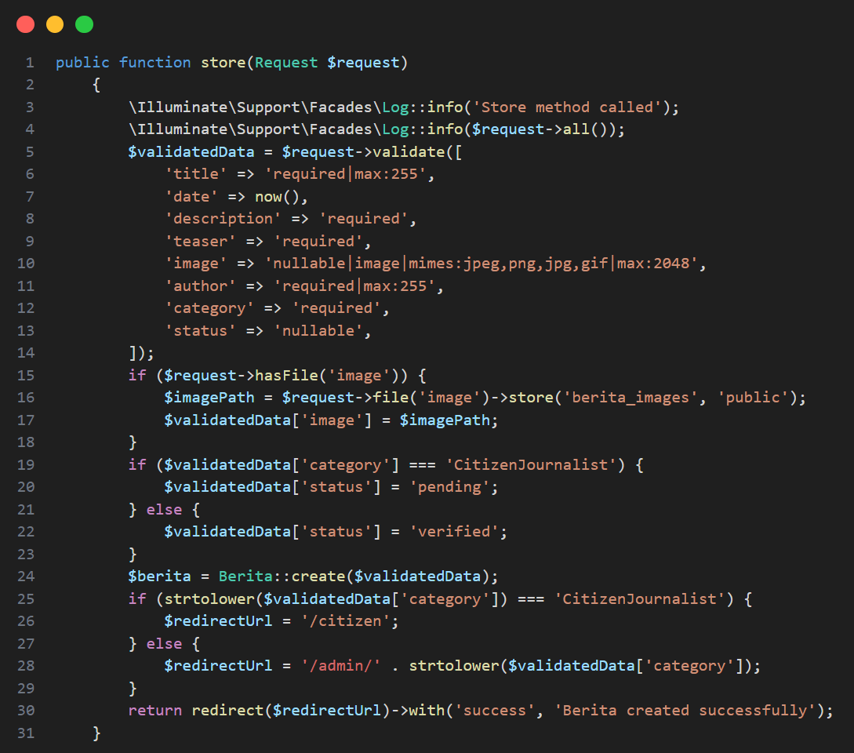

Scenario 1 :
Menambahkan berita dengan data valid
$$Statement coverage= \frac{20}{31}×100\%=64,5\%$$

Scenario 2 :
Menambahkan berita dengan form gambar kosong
$$Statement coverage= \frac{20}{31}×100\%=64,5\%$$

Scenario 3 :
Menambahkan berita dengan data invalid (salah satu form kosong)
$$Statement coverage= \frac{16}{31}×100\%=51,6\%$$

TC ID# | Input | Output | Statement Coverage | Status
TC-7 | Menambah berita dengan data valid | Berita berhasil ditambahkan | $$\frac{20}{31}×100\%=64,5\%$$ | Berhasil
TC-8 | Menambah berita dengan form image kosong | Berita gagal ditambahkan | $$\frac{20}{31}×100\%=64,5\%$$ | Berhasil
TC-9 | Menambah berita dengan data invalid | Berita berhasil ditambahkan | $$\frac{16}{31}×100\%=51,6\%$$ | Berhasil

- Edit berita
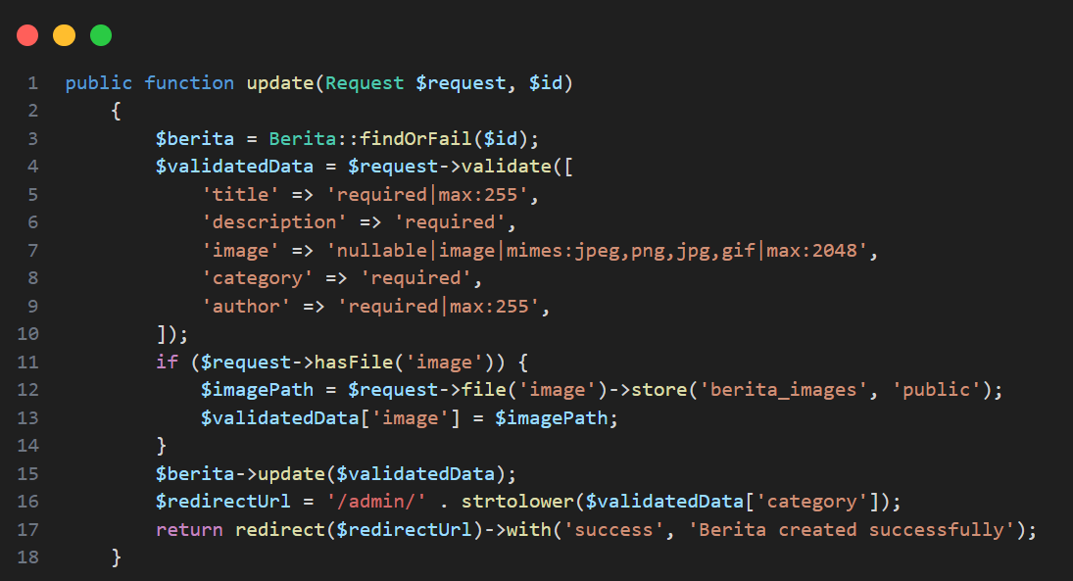

Scenario 1 :
Merubah berita dengan data valid
$$Statement coverage= \frac{18}{18}×100\%=100\%$$
Scenario 2 :
Merubah berita dengan image kosong
$$Statement coverage= \frac{11}{18}×100\%=61,1\%$$
Scenario 3 :
Merubah berita dengan data invalid (salah satu form kosong/melebihi batas inputan)
$$Statement coverage= \frac{11}{18}×100\%=61,1\%$$

Tugas Praktikum

- Teknik White Box Branch Coverage
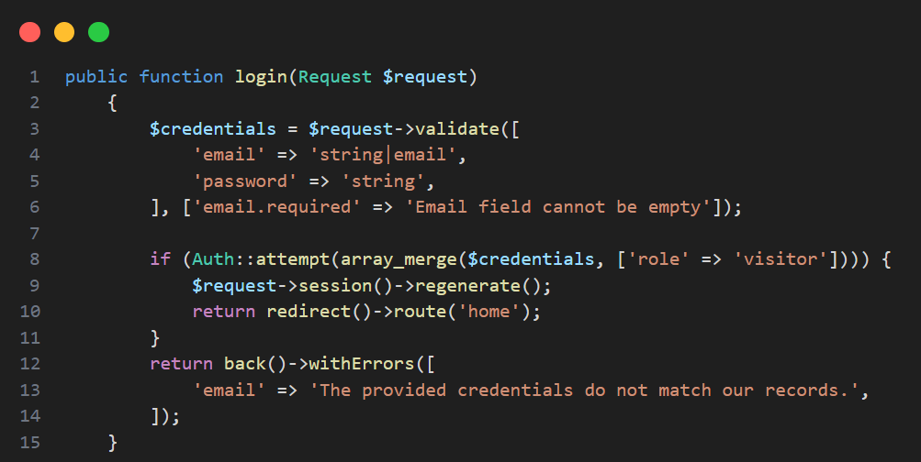
- Login

Skenario 1 : Validasi Email
      - Email Valid
      - Email Kosong
      - Email invalid
$$Branch Coverage= \frac{3}{3}×100\% = 100\%$$
Skenario 2 : Validasi Password
      - Password Valid
      - Password Kosong
      - Password invalid
$$Branch Coverage= \frac{3}{3}×100\% = 100\%$$
Skenario 3 : Autntikasi
            - Autentikasi Berhasil
            - Autentikasi Gagal
$$Branch Coverage= \frac{2}{2}×100\% = 100\%$$

Total Cabang : 8
Skenario | Covered Test Case | Branch Coverage
Skenario 1 | TC3 | $$\frac{3}{7}×100\% = 42.8\%$$
Skenario 2 | TC4 | $$\frac{3}{7}×100\% = 42.8\%$$
Skenario 3 | TC1, TC2 | $$\frac{2}{7}×100\% = 28.55\%$$


- Register

Skenario 1 : Validasi username (2 cabang)
  - Username kosong
  - Panjang username < 255
$$Branch Coverage= \frac{2}{2}×100\% = 100\%$$

Skenario 2 : Validasi password (2 cabang)
        - Password kosong
        - Panjang password > 8
$$Branch Coverage= \frac{2}{2}×100\% = 100\%$$

Skenario 3 : Validasi email (4 cabang)
        - Email kosong
        - Email valid
        - Email <255
        - Email unik
$$Branch Coverage= \frac{4}{4}×100\% = 100\%$$

Skenario 4 : Autentikasi Registrasi (2 cabang)
              - Autentikasi berhasil
              - Autentikasi gagal

$$Branch Coverage= \frac{2}{2}×100\% = 100\%$$

Total Cabang (Branches) = 10
Skenario | Covered Test Case | Branch Coverage
Skenario 1 | TC3 | $\frac{2}{10}×100\% = 20\%$
Skenario 2 | TC2 | $\frac{2}{10}×100\% = 20\%$
Skenario 3 | TC1 | $\frac{4}{10}×100\% = 40\%$
Skenario 4 | TC4 | $\frac{2}{10}×100\% = 20\%$


- Tambah berita

Skenario 1: Validasi Data (12 cabang)
  - Judul terisi
  - Judul < 255
  - Deskripsi terisi
  - Deskripsi >50
  - Teaser terisi
  - Teaser < 255
  - Image terisi
  - Image format sesuai
  - Image < 2MB
  - Author terisi
  - Author < 255
  - Kategori terisi

$$Branch Coverage= \frac{12}{12}×100\% = 100\%$$

Total Cabang (Branches) =
Skenario | Covered Test Case | Branch Coverage
Skenario 1 | TC15 & TC16 | $$\frac{12}{12}×100\% = 100\%$$


- Edit Berita

Skenario 1: Validasi Data Baru (12 cabang)
  - Judul terisi
  - Judul < 255
  - Deskripsi terisi
  - Deskripsi >50
  - Teaser terisi
  - Teaser < 255
  - Image terisi
  - Image format sesuai
  - Image < 2MB
  - Author terisi
  - Author < 255
  - Kategori terisi

$$Branch Coverage= \frac{12}{12}×100\% = 100\%$$

Total Cabang (Branches) = 14
Skenario | Covered Test Case | Branch Coverage
Skenario 1 | TC15 & TC16 | $$\frac{14}{14}×100\% = 100\%$$

- Teknik White Box Decision Coverage
$$Decision Coverage= \frac{Number of decision outcomes exercised}{Total number of decision outcomes}×100\%$$

- Login

Skenario 1 : Validasi email (2 pilihan)
  - Email valid (true)
  - Email invalid (false)
$$Decision Coverage= \frac{2}{2}×100\% = 100\%$$
Skenario 2 : Validasi password (2 pilihan)
        - Password valid (true)
        - Password invalid (false)
$$Decision Coverage= \frac{2}{2}×100\% = 100\%$$
Skenario 3 : Autentikasi (2 pilihan)
              - Autentikasi berhasil (true)
              - Autentikasi gagal (false)
$$Decision Coverage= \frac{2}{2}×100\% =100\%$$
Total Pilihan (Decisions) = 6
Skenario | Covered Test Case | Decision Coverage
Skenario 1 | TC3 | $$\frac{2}{6}×100\% = 33.33\%$$
Skenario 2 | TC2 | $$\frac{2}{6}×100\% = 33.33\%$$
Skenario 3 | TC1 & TC4 | $$\frac{2}{6}×100\% = 33.33\%$$


- Register
Skenario 1 : Validasi username
  - Panjang username <= 255 (true/false)
  - Username kosong ? (true/false)
$$Decision Coverage= \frac{4}{4}×100\% = 100\%$$
Skenario 2 : Validasi email
  - Email kosong (true/false)
  - Email sesuai format (true/false)
  - Panjang email <=255(true/false)
  - Email unik (true/false)
$$Decision Coverage= \frac{8}{8}×100\% = 100\%$$
Skenario 3 : Validasi password
  - Panjang password >= 255 ? (true/false)
  - password kosong ? (true/false)
$$Decision Coverage= \frac{4}{4}×100\% = 100\%$$
Total Pilihan (Decisions) = 16
Skenario | Covered Test Case | Decision Coverage
Skenario 1 | T3 | $$\frac{10}{16}×100\% = 62,5\%$$
Skenario 2 | T2 | $$\frac{8}{16}×100\% = 50\%$$
Skenario 3 | T1 & T4 | $$\frac{2}{16}×100\% = 12,5\%$$


- Tambah Berita

Skenario 1 : Validasi judul
  - Panjang judul <= 255 (true/false)
  - judul kosong (true/false)
$$Decision Coverage= \frac{4}{4}×100\% = 100\%$$
Skenario 2 : Validasi deskripsi
  - Panjang deskripsi > 50 (true/false)
  - deskripsi kosong (true/false)
$$Decision Coverage= \frac{4}{4}×100\% = 100\%$$
Skenario 3 : Validasi teaser
  - Panjang judul <= 255 (true/false)
  - Panjang teaser >10 (true/false)
  - judul kosong (true/false)
$$Decision Coverage= \frac{6}{6}×100\% = 100\%$$
Skenario 4 : Validasi image
  - image kosong (true/false)
  - file image sesuai format (true/false)
  - Size image < 2MB (true/false)
$$Decision Coverage= \frac{6}{6}×100\% = 100\%$$
Skenario 5 : Validasi author
  - author kosong (true/false)
  - panjang author <255 (true/false)
$$Decision Coverage= \frac{4}{4}×100\% = 100\%$$
Skenario 6 : Validasi categori
  - kategori kosong (true/false)
$$Decision Coverage= \frac{2}{2}×100\% = 100\%$$

Total Pilihan (Decisions) = 26
Skenario | Covered Test Case | Decision Coverage
Skenario 1 | TC15 & TC16 | $$\frac{4}{26}×100\% = 15.3\%$$
Skenario 2 | TC15 & TC16 | $$\frac{4}{26}×100\% = 15.3\%$$
Skenario 3 | TC15 & TC16 | $$\frac{6}{26}×100\% = 23\%$$
Skenario 4 | TC15 & TC16 | $$\frac{6}{26}×100\% = 23\%$$
Skenario 5 | TC15 & TC16 | $$\frac{4}{26}×100\% = 15.3\%$$
Skenario 6 | TC15 & TC16 | $$\frac{2}{26}×100\% = 7.6\%$$


- Edit Berita

Skenario 1 : Validasi judul baru
  - Panjang judul <= 255 (true/false)
  - judul kosong (true/false)
$$Decision Coverage= \frac{4}{4}×100\% = 100\%$$
Skenario 2 : Validasi deskripsi baru
  - Panjang deskripsi > 50 (true/false)
  - deskripsi kosong (true/false)
$$Decision Coverage= \frac{4}{4}×100\% = 100\%$$
Skenario 3 : Validasi teaser baru
  - Panjang judul <= 255 (true/false)
  - Panjang teaser >10 (true/false)
  - judul kosong (true/false)
$$Decision Coverage= \frac{6}{6}×100\% = 100\%$$
Skenario 4 : Validasi image baru
  - image kosong (true/false)
  - file image sesuai format (true/false)
  - Size image < 2MB (true/false)
$$Decision Coverage= \frac{6}{6}×100\% = 100\%$$
Skenario 5 : Validasi author baru
  - author kosong (true/false)
  - panjang author <255 (true/false)
$$Decision Coverage= \frac{4}{4}×100\% = 100\%$$
Skenario 6 : Validasi kategori baru
  - kategori kosong (true/false)
$$Decision Coverage= \frac{2}{2}×100\% = 100\%$$

Total Pilihan (Decisions) = 26
Skenario | Covered Test Case | Decision Coverage
Skenario 1 | TC15 & TC16 | $$\frac{4}{26}×100\% = 15.3\%$$
Skenario 2 | TC15 & TC16 | $$\frac{4}{26}×100\% = 15.3\%$$
Skenario 3 | TC15 & TC16 | $$\frac{6}{26}×100\% = 23\%$$
Skenario 4 | TC15 & TC16 | $$\frac{6}{26}×100\% = 23\%$$
Skenario 5 | TC15 & TC16 | $$\frac{4}{26}×100\% = 15.3\%$$
Skenario 6 | TC15 & TC16 | $$\frac{2}{26}×100\% = 7.6\%$$

